eSlide Manager User Guide: How to move or clone images
This SOP is a step-by-step guide to moving or cloning images in specimens to different specimens.
It is recommended to move slides when they are in the wrong folder or need to be placed in an updated folder.
The clone feature allows users to make a virtual copy in a new folder that points to the original image without making an actual copy on the server. The clone feature allows for the image to be viewed from multiple projects/lessons or specimens.

Moving eSlides*
*Unfortunately, using the ‘Move’ button under eSlide Details requires knowledge of the destination file location which is a burdensome task. It is recommended to do the steps below instead of using the ‘Move’ button.
- At the specimen level, open the specimen of interest and identify the eSlide of interest by clicking the box to the left of it.
- Click the ‘Open Data’ button under eSlide Details.
- There are now 5 buttons that can be chosen (Add Image, Assign To New Specimen, Assign To Existing Specimen, Assign To New Project, Assign To Existing Project )
  - If you choose ‘Add image’ you will be able to add a picture to the opened eSlide.
  - If you choose ‘Assign To New Specimen’:
    - This will prompt you to make a new specimen within the same lesson.
    - Complete the specimen information and click add
    - Your eSlide can now be found in the newly assigned specimen
  - If you choose ‘Assign to Existing Specimen’
    - A list of lessons will appear. If you see your lesson or project in the listing at the bottom of the screen, click the box next to it and then click ‘assign’.
    - If you don’t see the desired destination, use the filters at the top of the page.
      - Hit ‘+’ to the left of the desired location (course, lesson or specimen)
      - Click on the identifier of the desired location; i.e. Lesson Name
      - Enter the name of the desired lesson in the box (it will pop up shortly after you started typing)
      - Click ‘Apply Filter’
    - Click the box next to the lesson and click ‘Select’
Cloning eSlides
- Identify the eSlide that will be cloned. Record its ‘Slide ID’ number for use in the next step.
- If you want to move the slide to an existing Specimen or Lesson, identify the number of the target Specimen or Lesson.
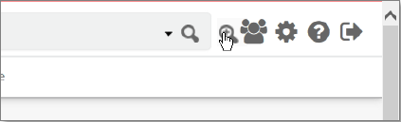
- Click the Advanced Search icon
- Use the Search For list under Modify Search Criteria, select the level for which you would like to start your search.
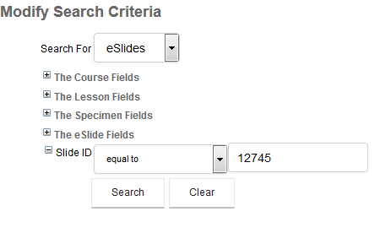
  - Enter the ‘Slide ID’ that you recorded previously and click ‘Search’
- Identify the eSlide by clicking the box to the left of it.
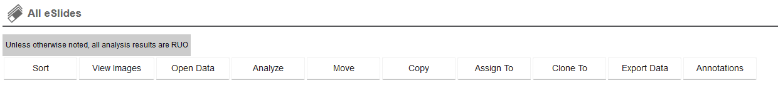
- Third from the right is the ‘Clone To’ button.
- A drop-down box will appear in which you can choose to assign to an Existing Specimen or Lesson; or, a New Specimen or Lesson.
- Identify the location for which you would like to clone the eSlide to and click ‘Select’.

